Course id: BIT 116
Course Name: Maths I
Program: BIT FALL 2019

Semester: 1 Year/ I semester




BACHELOR IN INFORMATION TECHNOLOGY

ASSIGNMENT

Submitted by:

Submitted to:

Name: Sunil Kumar Goley Tamang

Year/ Semester: First, Fall 2019

LCID: LC00017000862

Name: Lincoln University

Date: 2020.06.03

Sunil Kumar Goley Tamang Page 1

Course id: BIT 116 |  |  | Course Name: Maths I
 |  |  | Program: BIT FALL 2019
 |  |  | Semester: 1 Year/ I semester
1. Find the Domain and Range of |  |  | ( ) √
➢ Solution:
 | Here,
 | 2-x-x²=0
 | Or, (2+x) (1-x) = 0
 | Either, x =1 or, -2
 | The interval be (-∞,-2)U(-2,1)U(1,∞)
 | Now, the sign conversion,
 |  | 2+x |  | 1-x |  |  | (2+x)(1-x)
 | (-∞,-2) | - |  | + |  |  | -
 | (-2,1) | + |  | + |  |  | +
 | (1,∞) | + |  | - |  |  | -

Here, only the positive sign is taken. So, the Domain is found

to be (-2,1).

For range,

√

=√( )( )

For, minimum value we take x=0, then the output will be maximum value. So the Range is (0,√ ).

1. Find the solution of: + = 0

- Solution:

Here,

Integrating both side;
  - ∫

Or, tan⁻¹x +log(y+1) =0

- Differentiate:
  - Solution:

Given,

y= 4sect +tant

Differentiate with respect to t we get,
Or, |  | = | ( | )
Sunil Kumar Goley Tamang |  |  |  |  | Page 2

Course id: BIT 116
Course Name: Maths I
Program: BIT FALL 2019

Semester: 1 Year/ I semester

- If f”(x)=20x³-12x²+6x, then find f(x).

  - Solution:

Given,

f”(x) = 20x³-12x²+6x Integrating both sides we get,

Or, ∫ ( ) | ∫
Or, f’(x) =∫ | -12x²+6x

Or, f’(x) =

Or, f’(x) = 5x⁴-4x³+3x²
Integrating both sides we get,
Or, ∫ ( ) |  | ∫
Or, f(x) = |  |  |  | +

Or, f(x) = x⁵-x⁴+x³
Hence, f(x) is found to be x⁵-x⁴+x³.

- Find the area enclosed between x axis, the curve y= x³-2x+5 and the ordinates x=1 and x=2.

  - Solution:

Here,

Given,

y= x³-2x+5 x=1, x=2

Y
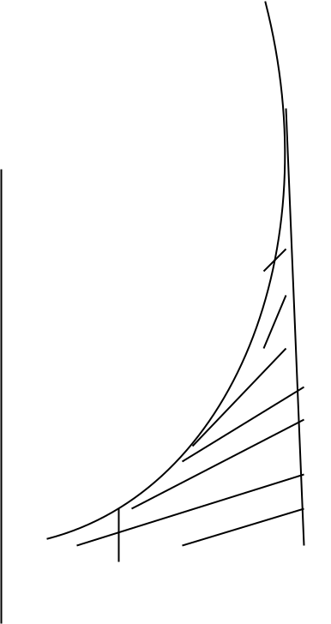

4

 |  | 1 | 2
0 |  | 1 | 2 | X
 | Sunil Kumar Goley Tamang |  |  | Page 3

Course id: BIT 116
Course Name: Maths I
Program: BIT FALL 2019

Semester: 1 Year/ I semester

From the formula;
Area= ∫ ( )

Now a=1 and b=2 then the function becomes
A= ∫

A= ₁²

A= [4-4+10]-[

A= 10-

A= 5.75 sq.unit

Hence, the area enclosed between x-axis is found to be 5.75 sq unit.
5. Find ∫ (Antiderivatives)

- Solution:

Given, Or, ∫ Or, ∫

Or, ∫ |  | dx -∫
Or, ∫ |  | ( ^{x}+1)
Or, x- ln(e^{x}+1) +C
Antiderivatives of the function ∫ |  |  |  |  |  | is found to be x-
ln(e^{x}+1)+C.

- State and Verify mean value theorem for f(x)= x³-x in [0,2]

  - Solution:

Here,

Given function is f(x) = x³-x which is continuous on close interval [a,b]

Then, there exist some number in c in [a,b] such that f’(c)
f’(c) = ⁽ ⁾ ⁽ ⁾

[a,b]=[0,2]

Then, a=0 and b= 2.

Sunil Kumar Goley Tamang Page 4

Course id: BIT 116
Course Name: Maths I
Program: BIT FALL 2019

Semester: 1 Year/ I semester

Now, f(a)=x³-x
Or, f(0)=0

f(b)= x³-x
f(2)= 6
Or, f’(c) = ⁽ ⁾ ⁽ ⁾

Or, f’(c) =

f’(c) =3 Again, f’(c)= 3x²

From above we found f’(c)= 3

Or, 3= 3x² Or, x= 1

Therefore, 1 lies between the interval 0 and 2. Hence, it proves mean value theorem.

Sunil Kumar Goley Tamang Page 5

